
Embassy of Japan in Israel
Newsletter July 2014

Dear friends & colleagues,

We are pleased to send you our 55th Economic Newsletter.

It is very encouraging to see a lot of exchanges between Japan & Israel in economic fields.
In May this year, PM Benjamin Netanyahu visited Japan and issued a Japan-Israel Joint Statement with PM Shinzo Abe.
In that statement, both PMs agreed to further strengthen economic ties between our two countries.

After this visit economic exchanges between Japan and Israel have become very active.

From July 5 to 7, 2014, Mr. Toshimitsu Motegi, Minister of Economy, Trade and Industry, visited Israel to hold follow-up meetings with PM Benjamin Netanyahu as well as Minister of Economy, Mr. Naftali Bennett. Both sides agreed to further promote the development and strengthening of economic, industrial, technological and commercial cooperation between Japan and Israel and furthermore, both Ministers signed an MOC (attached) to promote activities of their respective industrial sectors to intensify bilateral R&D cooperation.
Minister Motegi became the first METI Minister to visit Israel.

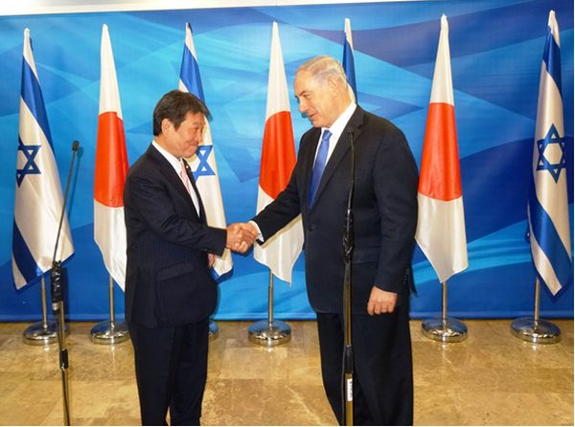

On July 6, The Israel-Japan Business Forum organised by JETRO, the New Energy and Industrial Technology Development Organization (NEDO) and the Japan Cooperation Center for the Middle East (JCCME) on the occasion of Minister Motegi's visit to Israel was held in Jerusalem. A total of 151 people attended the seminar, including representatives from governments and companies, Japanese companies operating and planning to do business in Israel as well as journalists.
At the forum, Minister Motegi expressed his strong hope that the two countries strengthened their economic partnership.

Secondly, from July 7 to 8, 2014, Mr. Yoshitaka Shindo, Minister of internal affairs and communications, visited Israel to meet Israeli communication Minister, Mr. Gilad Erdan. The two Ministers agreed to further promote official exchanges in this field and signed the Minutes of Meeting on Cooperation in the Field of Information and Communications Technology (attached). Mr. Shindo was the first Minister of Internal Affairs and Communications to visit Israel.

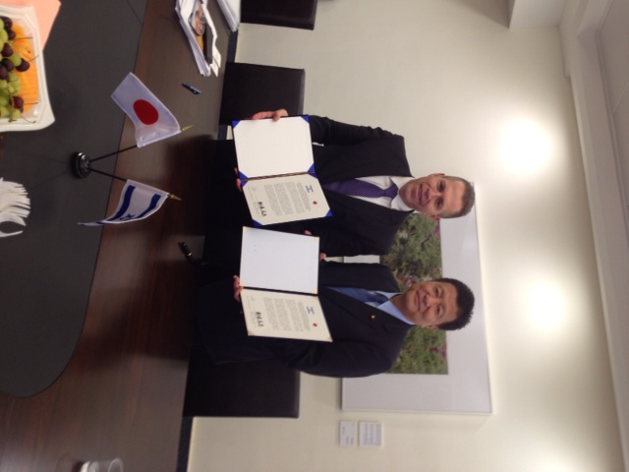

We are happy to inform you that the Israeli government and private sector are considering sending an economic delegation to Japan in mid-September.

We will update you on this visit in the September Newsletter….

We would like to take this opportunity to welcome our new commercial attaché, Mr. Osamu Maruyama.
As Mr. Maruyama gradually enters his new position, he will be glad to talk and meet you, our colleagues, and contribute as much as he can towards the strengthening of the Israeli-Japanese economic relations.

Embassy of Japan
Economic Section

Osamu Maruyama, Commercial Attaché
Masayuki Azemi, Commercial Attaché
Hideki Kamiya, Agriculture Attaché
Oded Schaffer, Economic Advisor

Monthly economic report – Cabinet Office
The Japanese economy is on a moderate recovery trend and a reaction after a last-minute rise in demand before a consumption tax increase is easing.
- Private consumption shows movements of picking up, while some weakness remains.
- Business investment shows some weak movements recently, while it is on the increase.
- Exports are flat.
- Industrial production is in a weak tone recently with a reaction after a last-minute rise in demand before a consumption tax increase.
- Corporate profits are improving. Firms' judgment on current business conditions shows cautiousness, while signs of improvement can be seen.
- The employment situation is improving steadily.
- Consumer prices are rising moderately.

http://www5.cao.go.jp/keizai3/getsurei-e/2014jul.html

Japan Revitalization Strategy

When the Abe administration was inaugurated, the Japanese economy was obsessed with a chronic deflationary mindset after an economic slump that lasted for more than 20 years. In response, the Abe administration launched the first arrow of bold monetary policy aimed at eliminating the deflationary mindset and the second arrow of flexible fiscal policy aimed at igniting the dampened economy. It has also formulated "Japan Revitalization Strategy” as the third arrow, implementing its bold speedy Growth Strategy.

http://www.kantei.go.jp/jp/singi/keizaisaisei/pdf/honbunEN.pdf

50 Years at the OECD

In May this year Japan headed the OECD Ministerial Committee. Japanese PM Shinzo Abe made a speech at the meeting, where he spoke about Japan's history and relations with the organization, including the mutual benefit during this long period. The PM also overviewed the current economic situation in Japan, explaining his "3 Arrow" policy and expressing the challenges facing Japan and the world in the coming 50 years.
http://japan.kantei.go.jp/96_abe/statement/201405/oecd.html

Why Japan? Three good reasons why you should open your business in Japan

The "3 Windows on Japan" is on the value of setting up new businesses in Japan. Discover the three advantages Japan offers foreign companies when investing in Japan; (1) Innovation Hub, (2) Business Platform and (3) Trendsetter.

http://www.jetro.go.jp/en/invest/whyjapan/pdf/3_windows20120911_en.pdf

Guidelines for developing health software formulated

In November 2013, the Act for Partial Revision of the Pharmaceutical Affairs Law was promulgated (Act No. 84 of 2013; scheduled to be enforced in November 2014). Under the Act, independent computer programs (medical software) for diagnoses and other purposes will be regulated as medical equipment stipulated in the Pharmaceutical Affairs Law, the name of which will be revised to the Act for Securing Quality, Effectiveness and Safety of Medical Products and Equipment, or the Medical Products and Equipment Act (tentative English translation) after the enforcement.

http://www.meti.go.jp/english/press/2014/0724_01.html

Regional economic and industrial research

METI has compiled the results of the regional economic and industrial research that the regional Bureaus of Economy, Trade and Industry conduct on a quarterly basis to identify regional economic trends.

http://www.meti.go.jp/english/press/2014/0729_01.html

Partial Revision of the Export Trade Control Order

On July 22, 2014, the Cabinet approved the required revision of the order concerning [i] addition and removal of goods to and from the regulatory list based on the agreements concluded at the International Export Control Conference in 2013 and [ii] centralized control of regulations, aiming to harmonize Japan’s systems with global systems, an approach bringing Japan into line with other countries and reducing burdens and reducing burdens imposed on businesses when enforcing treaties. METI hereby announces the revision.

http://www.meti.go.jp/english/press/2014/0722_05.html

Patent

The Japan Patent Office (JPO) published the Japan Patent Office Annual Report 2014.
The annual report comprises of a summary of the current situation and future directions surrounding the intellectual property (IP) system as well as domestic and overseas trends, together with an analysis of the system based on related statistical information.

http://www.meti.go.jp/english/press/2014/0514_04.html

Bring out the Strength of Japan!

Japan's businesses are facing various challenges related to their business development stages. In order to support these businesses in overcoming these challenges and leading Japan towards revitalisation, the government of Japan implemented the Industrial Competitiveness Enhancement Act.

http://www.meti.go.jp/english/publications/pdf/journal2014_05a.pdf

 Climate Change Campaign

The Ministry of the Environment has started its new climate change campaign called "Fun to Share" with a view to realizing a low-carbon society. "Fun to Share" aims to develop lifestyle innovations as well as the building of a low-carbon society.

http://www.env.go.jp/en/focus/140521.html#top

The Environment 2013

The Ministry of Environment issued the 2013 report on the Environment, the Sound Material-Cycle Society and the Biodiversity in Japan.
Chapters include treatment of the radioactive contaminated areas, changes in individuals' attitudes towards economic affluence and the environment, children's environment education human-nature harmony and more….

http://www.env.go.jp/en/wpaper/2013/index.html

528 Japanese regional brands' catalogue – in English

In April 2006, the Japan Patent Office (JPO) introduced the Regional Collective Trademark System, for the purpose of protecting and promoting Japan’s regional brands. As a part of JPO’s initiative for further promotion and utilization of the system, 528 cases from the already-registered regional collective trademarks are compiled into an English brochure titled “Regional Brands in JAPAN.”

http://www.jpo.go.jp/sesaku_e/pdf/regional_brands/regional2014.pdf

20m tourists by 2020

In the year 2013 Japan reached the goal of 10m tourists. It has now set itself a new, ambitious goal of reaching 20m tourists by the year 2020 – the year it will host the Olympic and para-Olympic games.
In order to achieve this ambitious goal the execution of the "Action Program" will be accelerated. This Programme includes activities at all levels – national, regional and individual – to promote and attract Japan as a Tourism Oriented Country.
In order to prepare an environment receptive to foreign travelers, efforts will be made to improve and strengthen multilingual guidance, measures such as expediting and streamlining immigration procedures at airports and ports, improving the convenience of public transport in response to the increasing number of people traveling alone, promoting the voluntary establishment of free public wireless LAN, preparing the shopping environment (all items of cosmetics, confectionary and similar products that are popular with foreigners will be made duty-free from October this year, installation of ATMs that are compatible with credit cards issued overseas as well as making it possible to pay for even small-sum items using credit cards and debit cards), and much more.

We invite you to read the message of the director of the Japan Tourism Agency and visit Japan –

http://www.mlit.go.jp/kankocho/en/about/message.html

Tourism. Industrial Tourism.

Japan is well known for as a top-tourism destination for its nature and all aspects of culture. Why not add an industrial tour to your next trip to Japan?
Here you will find a couple of options suitable to your interest (factory tours, plant tours, craft centres, industrial museums, farm tours, brewery tours and more) and region of travel.

http://www.jetro.go.jp/en/ind_tourism/?print=1

Foodex Japan, 2015

As booth holders or guests – if you are in the food business this is the place to be! Asia's largest food exhibition since 1976, held in Tokyo, Japan.
Foodex Japan, 3-5 March, 2015

http://www.jetro.go.jp/en/events/foodex2015/

